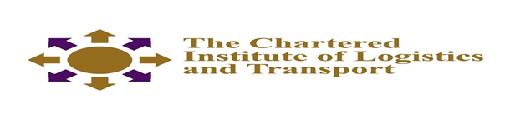
CERTIFICATE IN LOGISTICS AND TRANSPORT
Procurement

November 2021
Note to Candidates
Candidates are advised to spend NOT more than 60 minutes in Section A and not more than 40 minutes on each question in section B. Credit will be given for citing relevant examples.
2.30 hours
Answer question 1 in Section A and any 3 questions from section B
_________________________________________________________________________

SECTION A
Question 1.
(a) Define the term procurement (3 marks)
(b) List stages of the procurement process (5 marks
(c) List five documents that are used in procurement (5 marks)
(d) Briefly explain 3 reasons that have pushed companies towards global sourcing (6 marks)
(e) Using practical examples, explain the following terms as they apply to law of contract
- Offer ( 3 marks )
- Acceptance ( 3 marks)
- Consideration (3 marks)
(f) What are the qualities of a good supplier? ( 4 marks)
(g) List three benefits of single sourcing. ( 3 marks)
(h) List ways of risk minimisation in procurement (5 marks)
Section B
Question.2
Examine the characteristics of the different types of supplier relationships. (14 marks)

Question.3
List and explain the different sourcing strategies available to an organisation of your choice. (20 marks)
Question 4
(a) Discuss the role of ethics in the field of procurement (10 marks?)
(b) As a Procurement Manager, how can you ensure that ethical conduct is exercised in
your organisation (10 marks)
Question 5
‘Procurement plays a critical role in supply chain operations’. Discuss (20 marks)
Question 6
Explain the main criteria that should be used in selecting suppliers (20 marks)

