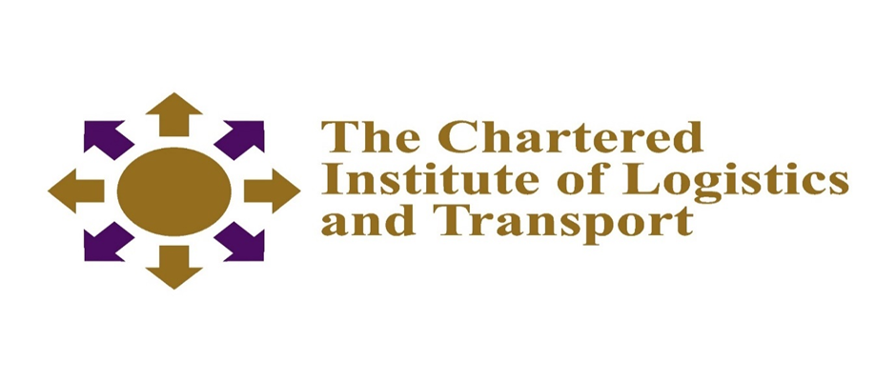
CERTIFICATE IN LOGISTICS AND TRANSPORT
FREIGHT TRANSPORT OPERATIONS (05-L3)
DECEMBER 2021
Duration 2.30 HOURS
Instructions to Candidate
ANSWERS ANY FIVE (5) QUESTIONS
Start each question on a new page.
Credit will be given for citing relevant examples.
Write legibly
_____________________________________________________________________
Question 1
- More formally, main decisions made at the tactical level concern the following issues:
- Service selection
- Traffic distribution
- Terminal policies
- General empty balancing strategies
Briefly discuss the activities at each of the above decision
[14 marks]
- Highlight three levels of planning in a typical freight operations environment
(6 marks]
Question 2
Define the following terms
- Regulation [4 marks]
- Cabotage [4 marks]
- Monopoly [4 marks]
- Privatisation [4 marks)
- Bill of Lading [4 marks

Question 3
- Outline specific measures that can be put in place to ensure effective green fleet management [10 marks]
- Discuss the advantages of rail transport for urban freight distribution [10 marks]
Question 4
Identify and discuss supply characteristics of Freight transport [20 marks]
Question 5
Using examples outline the strategies that have been adopted in your country to limit the growth of road freight transport. [20 marks]
Question 6
Discus how each of the following parameters affect the freight transport sector:
- Information and communication technologies [10 marks]
- Economic regulation of careers [10 marks]

