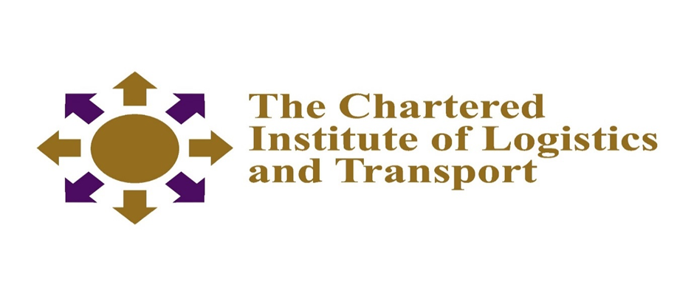
INTERNATIONAL CERTFICATE IN LOGISTICS AND TRANSPORT
SUPPLY CHAIN OPERATIONS 07-L3
November 2021
Notes to Candidates
Credit will be given for citing relevant examples. Write neatly and legibly
Instructions to Candidates
- Answer ALL questions in Section A.
- Answer any 3 questions in Section B.
- Start each question on a new page

2.30 HOURS

SECTION A
Question 1
Define the following techniques in supply chain operations.
- Operations management (4 marks)
- Production management (4 marks)
- Materials management (4 marks)
- Logistics management (4 marks)
- Transport management (4 marks)
SECTION B
Question 2
Discuss the advantages and benefits of agile logistics in supply chain operations? (20 marks)
Question 3
Citing relevant examples, evaluate the impact of any five internal environment factors on the operations of supply chain (20 marks)
Question 4
Explain how labeling is essential for reverse flows in supply chains. (20 marks)
Question 5
What is customer service and how helpful is it to an organisation in the supply chain operations. (20 marks)
Question 6
State and explain any five activities that drive supply chain operations. (20 marks)

