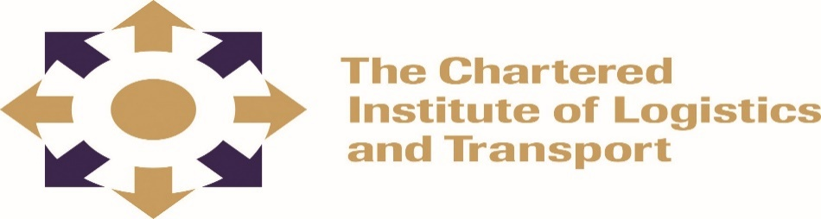

CHARTERED INSTITUTE OF LOGISTICS AND TRANSPORT
INTERNATIONAL ADVANCED DIPLOMA IN LOGISTICS AND TRANSPORT

ADIP-04 DELIVERING STRATEGIC PERFORMANCE

February 2022
Note to Candidates
The aim of this paper is to establish a learner’s understanding of the general principles and applications involved in Delivering Strategic Performance. Candidates are encouraged to write critically and make use of relevant examples where applicable.

Duration 3 HOURS

Instructions to Candidates

ANSWERS ANY FOUR (4) QUESTIONS
______________________________________________________________________
Question 1
Elucidate why supply chain firms engage in performance measurement? (25 Marks)

Question 2
Evaluate the key advantages and disadvantages of a strategy of supplier partnership
(25 Marks)

Question 3
In your own words, with practical examples differentiate between performance measurement and performance management. (25 Marks)

Question 4
‘Change management is a process which every organisation will go through. The transition is smoother in some organisations than is the case in others’. Identify and discuss any barriers to change management.
(25 Marks)

Question 5
Discuss how organizational culture would affect the strategic performance of a firm. (25 Marks)

Question 6
With practical examples, discuss the role of electronic data interchange on supply chain Performance
(25 Marks)

