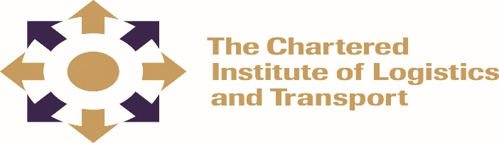

CERTIFICATE IN LOGISTICS AND TRANSPORT
FREIGHT TRANSPORT OPERATIONS (05-L3)
February 2022

Note to Candidates
Credit will be given for citing relevant examples. Write neatly and legibly.
Instructions to Candidates
- Answer ALL questions in Section A.
- Answer any 3 questions in Section B.
- Start each question on a new page

2.30 HOURS

SECTION A: COMPULSORY

- Provide details of the rights and responsibilities of the seller and buyer under the following Incoterms:
- FOB - Free On Board (5 marks)
- DDP - Delivered Duty Paid (5 marks)
- CIP - Carriage and Insurance Paid To (5 marks)
- CIF - Cost , Insurance and Freight (5 marks)

- (i) Define the term multi modalism. (2 marks)
(ii) Why is multi modalism important in freight operations? (4 marks)

- Citing examples, what is the difference between variable cost and indirect costs?
(4 marks)

- Identify any 3 strengths and weakness of pipeline transport. (6 marks)

- List any four factors to consider when establishing a new freight operation. (4 marks)

SECTION B: Answer any three questions

Question 1

AZ Ltd is an engineering company and imports components from overseas which it manufactures into valves for export overseas. Evaluate with examples the processes for both importing and exporting undertaken by the company. (20 marks)

Question 2

AA Impex is already an exporter, but has just started importing materials from overseas, and needs to ensure that it can have its consignments cleared quickly through Customs. What is the importance and nature of import and export documentation to the company? (20 marks)

Question 3

Describe the process and importance of freight forwarder in shipping. (20 marks)

Question 4

- Assess the methods of international trade finance available to a company involved in exporting overseas. (12 marks)

- What are the advantages and disadvantages of using each method? (8 marks)

Question 5

Explain with examples the role and responsibilities of the shipping agent in shipping practice. (20 marks)

Question 6

Evaluate the importance of border controls and the role of Customs in the export and import clearance of goods. (20 marks)

Question 7

- Why is supplying the correct details of containerized dangerous goods to the port authority or customs when importing and unloading these goods important?
(15 marks)

- What are the consequences of failure to do so? (5 marks)

