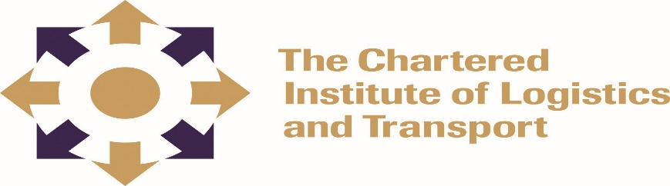
INTERNATIONAL CERTIFICATE IN LOGISTICS AND TRANSPORT

GLOBAL LOGISTICS 010-L3
February 2022
Notes to Candidates
Candidates are advised to spend advised not to not more than 45 minutes on each question. Credit will be given for citing relevant examples. Write neatly and legibly.
Duration: 2.30 hours
Answer ALL questions in Section A (Compulsory) and any 3 questions from Section B

Section A: COMPULSORY
- Explain the following Incoterms
i. CRF (Cost of Freight)
ii FCA (Free Carrier)
iii CPT (Carriage Paid To)
iv CIP (Carriage and Insurance Paid)
v DDP (Delivered Duty Paid) (10 marks)

- i. ICAO is a UN agency representing what interests?
ii. What are the duties of CAA in your country?
iii. What does OTIF represent?
iv. What is a free trade agreement?
v. Why are permits important in the movement of goods between countries?
(10 marks)
c) i. Cultural considerations can affect the flow or movement of goods internationally
Clarify on this statement. (4 marks)
ii. Why is business ethics important in a business entity? (4 marks)
- What are the advantages and disadvantages of bulk purchasing in the sourcing of goods? (4 marks)
- JIT is a method of supplying goods and material at the exact time they are required. It aims at achieving zero inventories.
    - List any 5 essential elements for an efficient JIT. (5 marks)
    - Can JIT work in Zimbabwean context? (3 marks) [Total 8 marks]
SECTION B: Answer any three questions
Question 1
- What does Economies of Scale entail? [8 marks]
- What are the advantages and disadvantages of Incoterm EXW to both the seller and buyer when used to move goods internationally? [12 marks]
Question 2
As a Logistics Manager of a global supply chain organization, you have detected that you have a supplier who is unable to supply you with the full amount of goods you order from them every week. The supplier acknowledges that there is a problem and has asked you to help put things right.
Suggest at least 5 possible KPIs that you may elect to use to ascertain the true extent of the problem. Briefly explain the relevance of each KPI. (20 marks)

Question 3
‘Risk assessment techniques are often applied to business planning when a company is trying to assess various options in an attempt to find a preferred option’.
Outline and explain any six key elements of risk assessment. (20 marks])

Question 4
‘Transport and supply chain ancillary and services are of paramount importance to global logistics’.
Write brief notes on the following ancillary operations and services; 3PL, Sub Contractors, Clearing Houses, Groupage Services and Break Bulk services. (20 marks)
Question 5
What are the advantages and disadvantages of each of the four modes of transport used to move goods across the globe and provide examples of goods that each mode is most suitable to carry and why? (20 marks)

