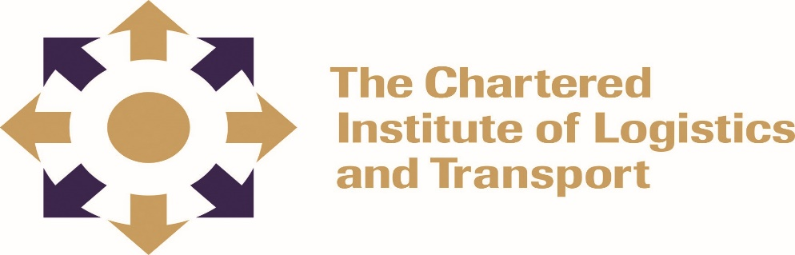
INTERNATIONAL DIPLOMA IN LOGISTICS AND TRANSPORT
MANAGEMENT IN LOGISTICS AND TRANSPORT: DIP01
FEBRUARY 2022

Instructions to Candidates
- Duration of examination: 3 hours
- Answer four questions
- Questions may be answered in any order
- Allocation of marks is indicated along each question
- Credit will be given for citing relevant examples
- Write legibly
----------------------------------------------------------------------------------------------------------------
Question 1
‘Leadership and management are essential capabilities in the operation of any enterprise and it is rare to find an activity where one will only require just one or the other’. Using examples from a Logistics and Transport environment discuss the complementary nature of leadership and management roles. (25 marks)
Question 2
Discuss any five external environmental factors that would impact upon the performance of a typical logistics and transport company in Zimbabwe. (25 marks)
Question 3
- Describe the core stages of succession planning? (10 marks)
- What is Maslow’s Hierarchy of Needs Motivation Theory? (15 marks)

Question 4
Consider the following types of business organisation in terms of their structure.
- Sole trader (5 marks)
- Partnership (5 marks)
- Limited company (5 marks)
- Public limited company (5 marks)
- Co-operatives (5 marks)

Question 5
‘The publication of formal company accounts is a method by which the directors are held to account for the performance of a company’. In the context of the foregoing statement discuss the significance of the auditors’ report, the balance sheet, and the profit and loss account. (25 marks)

Question 6
Describe the stages of team development and discuss the strengths and weaknesses of homogeneous and heterogeneous groups who may be constituted into work-teams (25 marks)

