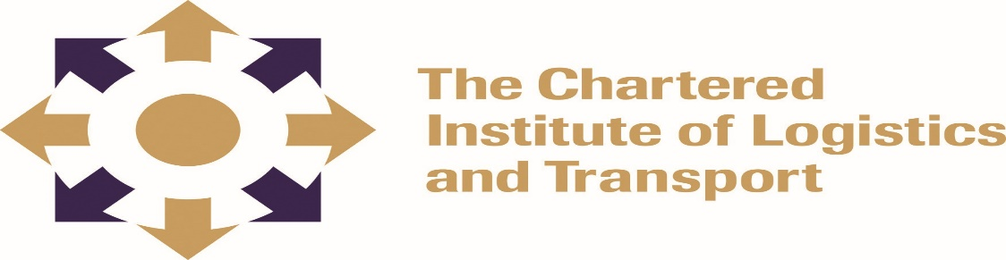
DIPLOMA IN LOGISTICS AND TRANSPORT
PROJECT PLANNING DIP15

FEBRUARY 2022

Note to Candidates
Credit will be given for citing relevant examples. Write neatly and legibly.
Instructions to Candidates
- Answer any 5 questions.
- Start each question on a new page

3 HOURS
__________________________________________________________________________________
Question 1
- Define project integration management. [2 marks]
- State any four main purposes of project evaluation. [8 marks]
- Explain two ways in which empowered teams could improve the success of a project.
(10 marks)
Question 2
- Explain any four (4) main elements of project feasibility analysis. [8 marks]
- State and explain any four (4) project screening methods. [8 marks]
- What are the two (2) methods of project budgeting? [4 marks]

Question 3
Identify and explain the main approaches to cost estimation in Project Management. (20 marks)

Question 4
- List and explain any four types of change management which can be adapted to suit varying areas of project management. [12 marks]
- What is the importance of change management? (8 marks)

Question 5
- Outline two major sources of risk that can impact a project. [2 marks]
- Explain one means of risk analysis, illustrating its main tools or technique
(6 marks)
- At which stage of a project life cycle is risk likely to be at its greatest and why?
(12 marks)
Question 6
Why would you use (SWOT) Analysis before engaging in a project? [20 marks]

Question 7
Compare ways in which contemporary organisations use numeric and nonnumeric project selection models [20 marks]

