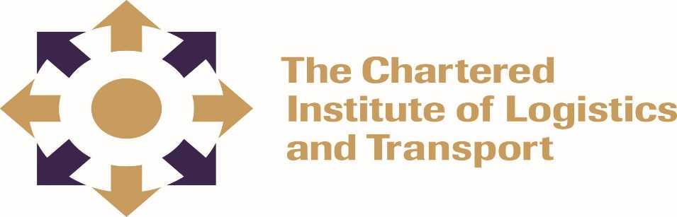
INTERNATIONAL ADVANCED DIPLOMA IN LOGISTICS AND TRANSPORT
STRATEGIC CONTEXT ADIP01
FEBRUARY 2022

3 HOURS
Instructions to Candidates
- Answer any four questions
- Questions may be answered in any order
- Allocation of marks is indicated alongside each question
- Credit will be given for citing relevant examples
- Write legibly
____________________________________________________________________
Question 1
Your company is considering engaging in global sourcing. With reference to Third Party Logistics discuss the significance of outsourcing as a competitive strategic initiative. (25 marks)

Question 2
Discuss how the seven wastes outlined by Taiichi Ohno (1988) could be used to develop and implement a system to monitor and evaluate industrial performance to ensure compliance with the respective industry standards or legislation. (25 marks)

Question 3
- How would you assess the business risks associated with a strategic proposal for an organisation of your choice? (20 marks)
- Outline the contingency plan/s that may be implemented to mitigate the risks. (5 marks)

Question 4
With reference to the Southern African Development Community (SADC) discuss the potential logistics and transport challenges arising from the effects of COVID19 on a supply chain of your choice as well as strategic measures that can be taken to address the challenges. (25 marks)

Question 5
- What is the purpose of stakeholder mapping in the context of change management. (5 marks)
- Discuss the following stakeholder mapping tools.
- The Power/Dynamism Matrix (10 marks)
- The Power/Interest Matrix (10 marks)

Question 6
Write notes on the following market structures:
- Monopoly (8 marks)
- Oligopoly (7 marks)
- Cartel (5 marks)
- Monopsony (5 marks)

