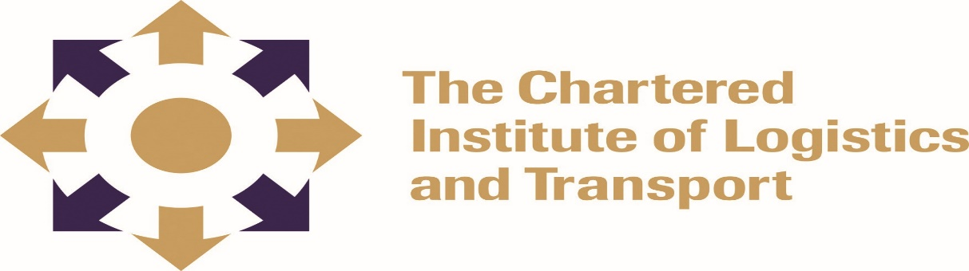

DIPLOMA IN LOGISTICS AND TRANSPORT
SUPPLY CHAIN MANAGEMENT DIP02
February 2022
Note to Candidates
Candidates are advised to spend NOT more than 60 minutes in section A and not more than 40 minutes on each question in section B. Credit will be given for citing relevant examples.
3 hours
Answer ALL Questions in Section A and any 3 questions from Section B
__________________________________________________________________________

Section A: COMPULSORY
- What is Balanced Scorecard (BSC) and its purpose. (4 marks)
- Explain the perspectives of the BSC (8 marks)
- What are the common elements that make up each perspective? (8 marks)
- What are the strengths and weaknesses of the scorecard? (10 marks)
- Why does balanced scorecard fail in some organisations? (10 marks)

Section B: Choose any three questions
Question 1
“A chain is only as good as its weakest link”. Explain in detail the implications of this statement as it relates to supply chain operations. (20 marks)

Question 2
Discuss at least any five key drivers to increase outsourcing by big organisations like OK Zimbabwe. (20 Marks)

Question 3
Demonstrate the Value Chain concept and its importance. (20 marks)

Question 4
Explain how a company of your choice has benefited or can benefit from at least two types of benchmarking? (20 marks)

Question 5
What are the key components of customer service? (20 marks)

