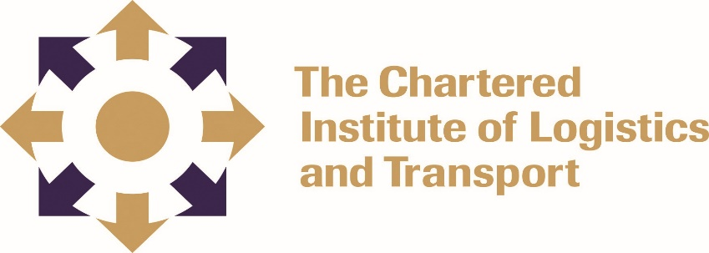

CERTIFICATE IN LOGISTICS AND TRANSPORT
SUPPLY CHAIN OPERATIONS 07-L3

FEBRUARY 2022

Note to Candidates
Credit will be given for citing relevant examples. Write neatly and legibly.
Instructions to Candidates
- Answer any 5 questions
- Start each question on a new page

Duration: 2.30 HOURS

Question 1

Information technology supports internal operations and collaboration between companies in a supply chain. Using high-speed data networks and databases, companies can share data to better manage the supply chain as a whole and their own individual positions within the supply chain. The effective use of technology is a key aspect of a company’s success.

Assess the technology that is available to support and sustain effective supply chain operations in a company of your choice. [20 marks]

Question 2

Explain how a company of your choice that has created customized supply chains for its customers could create a strong competitive advantage for itself? [20 marks]

Question 3

Evaluate methods such as collaborative planning, forecasting, and replenishment (CPFR) to improve coordination and combat the bullwhip effect [20 marks]

Question 4

Evaluate with relevant examples the impact of any five internal factors on the operations of a supply chain [20 marks]

Question 5

Apply the market-analysis framework to define the type of markets your company serves and identify the performance capabilities most valuable to those markets? [20 marks]

Question 6
Suppose you have been advised that your function has a high fixed overhead and that you should find ways of reducing this, what measures could you take to manage this overhead? [20 marks]

