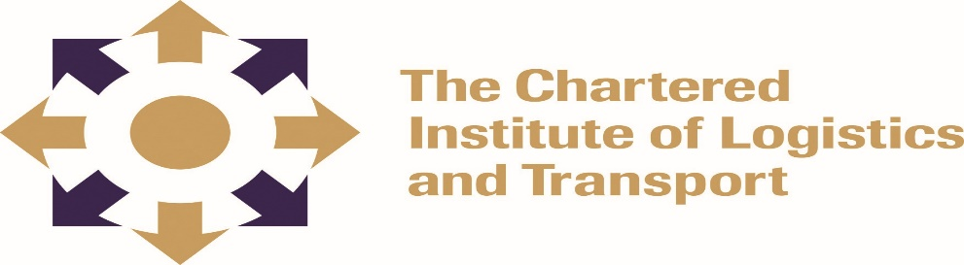
CERTIFICATE IN LOGISTICS AND TRANSPORT

O1-L3 WAREHOUSING

February 2022

Note to Candidates
Candidates are advised to spend NOT more than 60 minutes in Section A and not more than 40 minutes on each on each question in Section B. Credit will be for citing relevant examples. Write neatly and legibly.

Answer ALL Questions in Section A and any 3 questions in Section B. All Questions in Section B carry equal marks

2:30 HOURS

Section A: COMPULSORY (Answer the whole of Question 1)

a) Explain your understanding of the following terms:
i)Crossdocking (4 marks)
ii)Transshipment (4 marks)
iii) Outsourcing (4 marks)
iv) Quarantine area (4 marks)
v)FEFO (4 marks)
b). What are the five common risks in a warehouse and how can they be minimized? (10 marks)
c) Compare goods to picker and picker to goods picking systems (10 marks)

Section B: Answer any three questions

Question 1
List any five (5) warehouse KPIs and explain how they improve the output in a warehouse. (20 marks)

Question 2
Describe the four major warehousing processes and assess their importance for a successful warehousing operation (20 marks)

Question 3
What is the role of warehouses in the following supply chain systems?
- Push system (7 marks)
- Pull system (7 marks)
- Agile system (6 marks)

Question 4
Explain the common problems in a warehousing and prescribe ways in which they can be minimized. (20 marks)

Question 6
Discuss with relevant examples how ICT systems can be used to improve warehouse efficiency (20 marks)

